SQL Project
Employee Attrition Analysis

- Total Employees
select
count(*) as Total_Employees
from emp_attrition
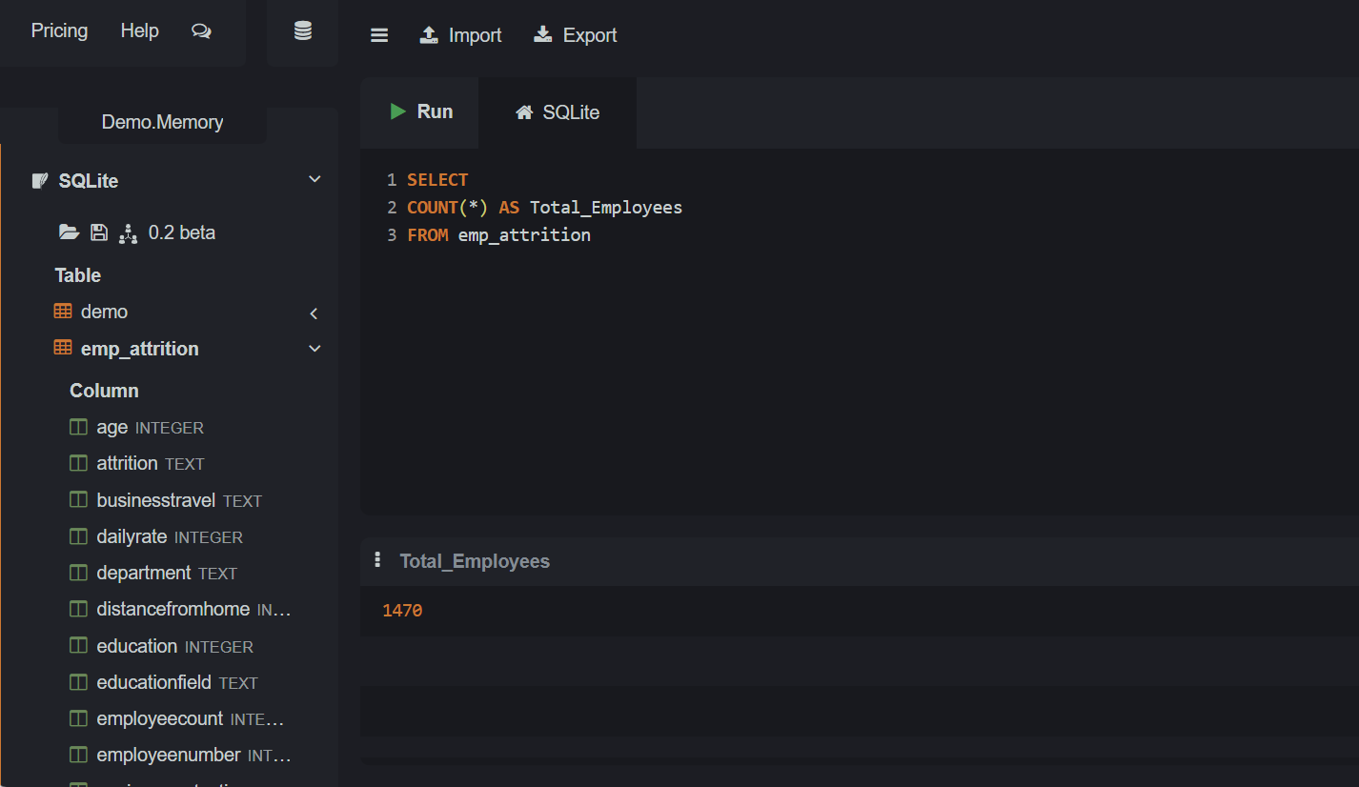

- Total Attrition
select count(attrition) from emp_attrition
where attrition = 'Yes'
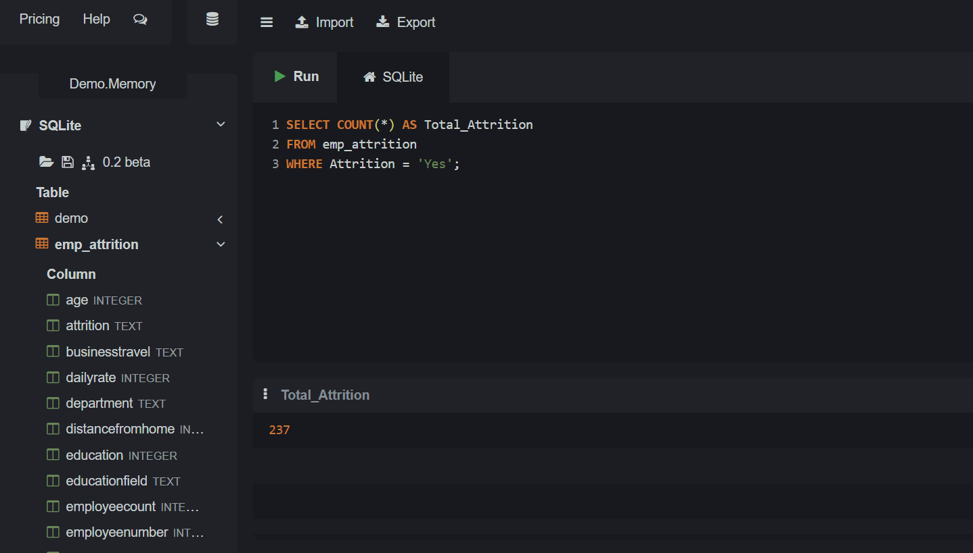

- Department-wise Attrition
select department,
count(*) as Attrition_Count from emp_attrition
where attrition = 'Yes'
group by department
order by Attrition_Count
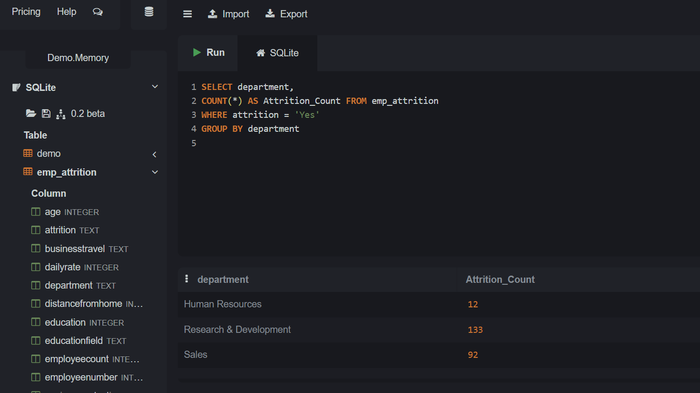

- Job Role-wise Attrition
select jobrole, count(*) as Employee_Attrition_Count
from emp_attrition
where attrition = 'Yes'
group by jobrole
ORDER by Employee_Attrition_Count DESC;
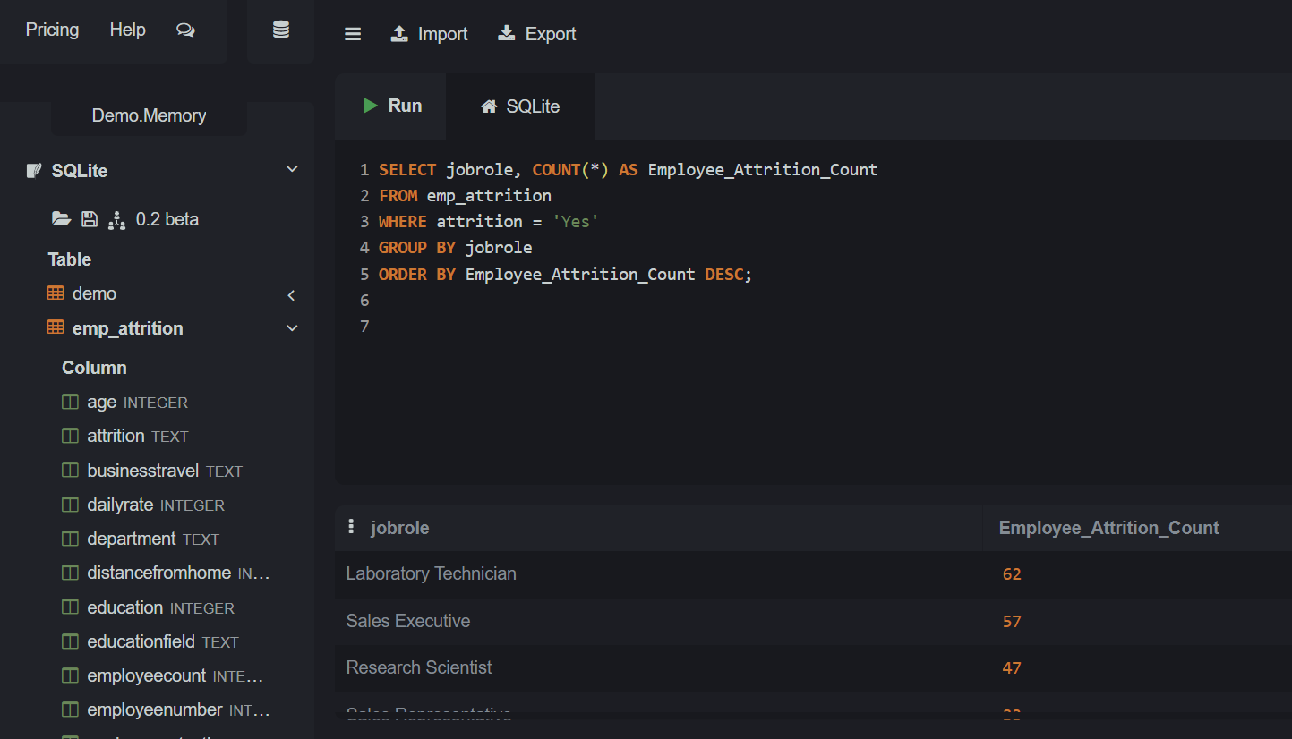

- Gender-wise Attrition
select gender, count(*) as Attrition_Count from emp_attrition
where attrition = 'Yes'
group by gender
order by Attrition_Count desc
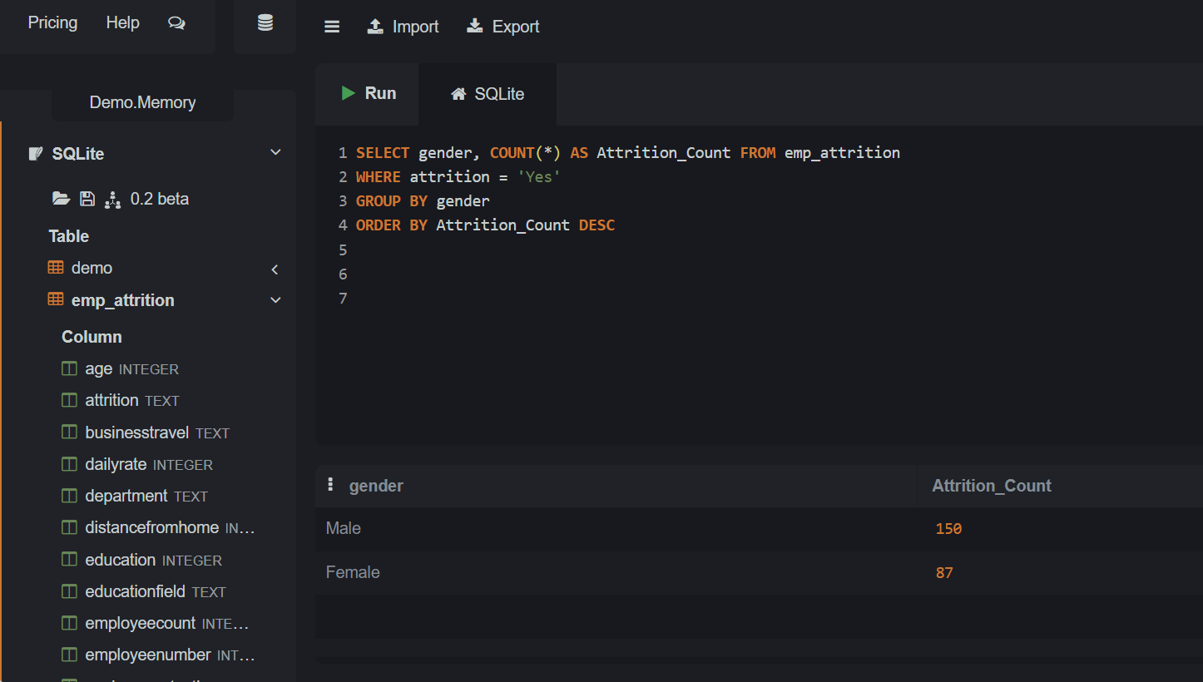

- Age Group Analysis
select case WHEN age>50 then 'Above 50'
when age>40 then '41 to 50'
when age>30 then '31 to 40'
when age>20 then '21 to 30'
else 'Below 20'
END as Age_Group,
Count(*) as Employee_Count
from emp_attrition
group by Age_Group
order by Employee_Count desc
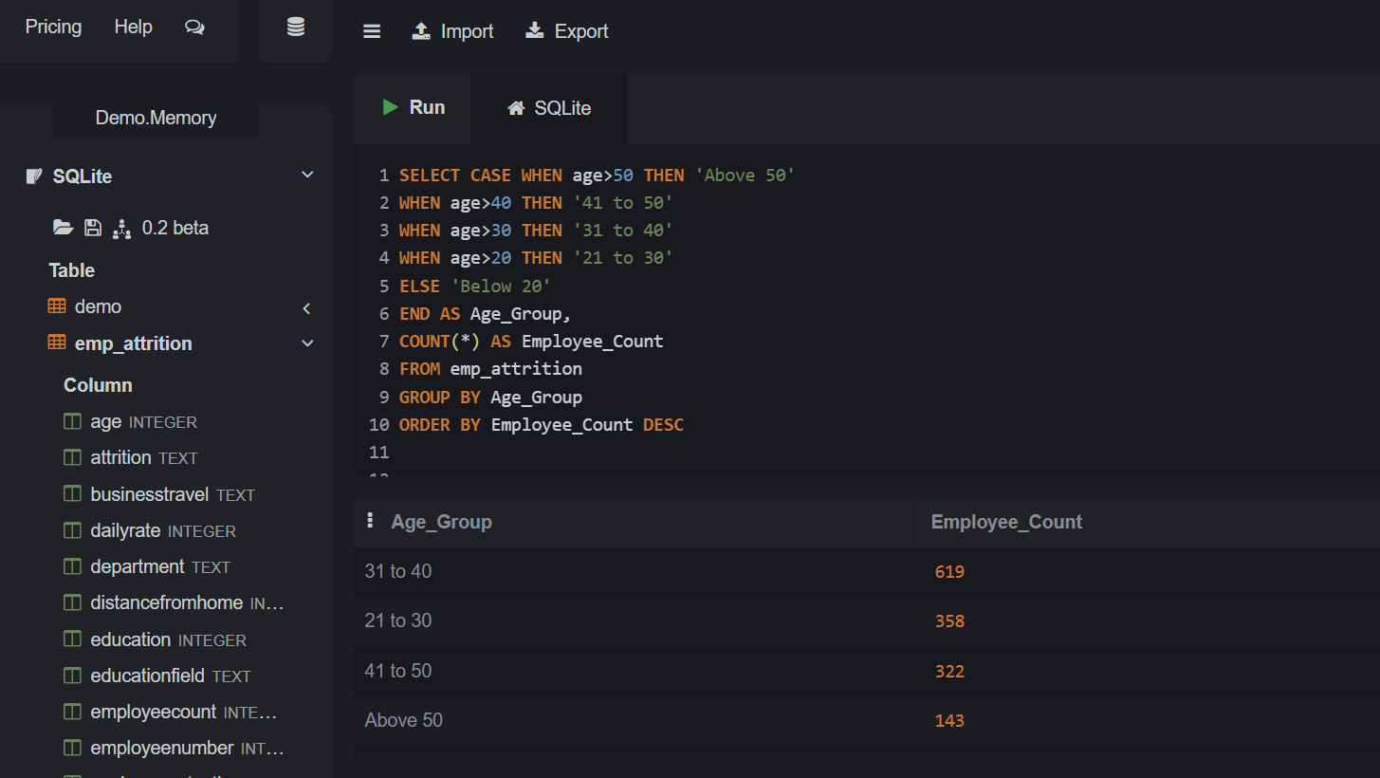

- Average Monthly Income by Department
SELECT department,
Avg(monthlyincome) as Avg_Monthly_Income
from emp_attrition
group by department
order by Avg_Monthly_Income desc
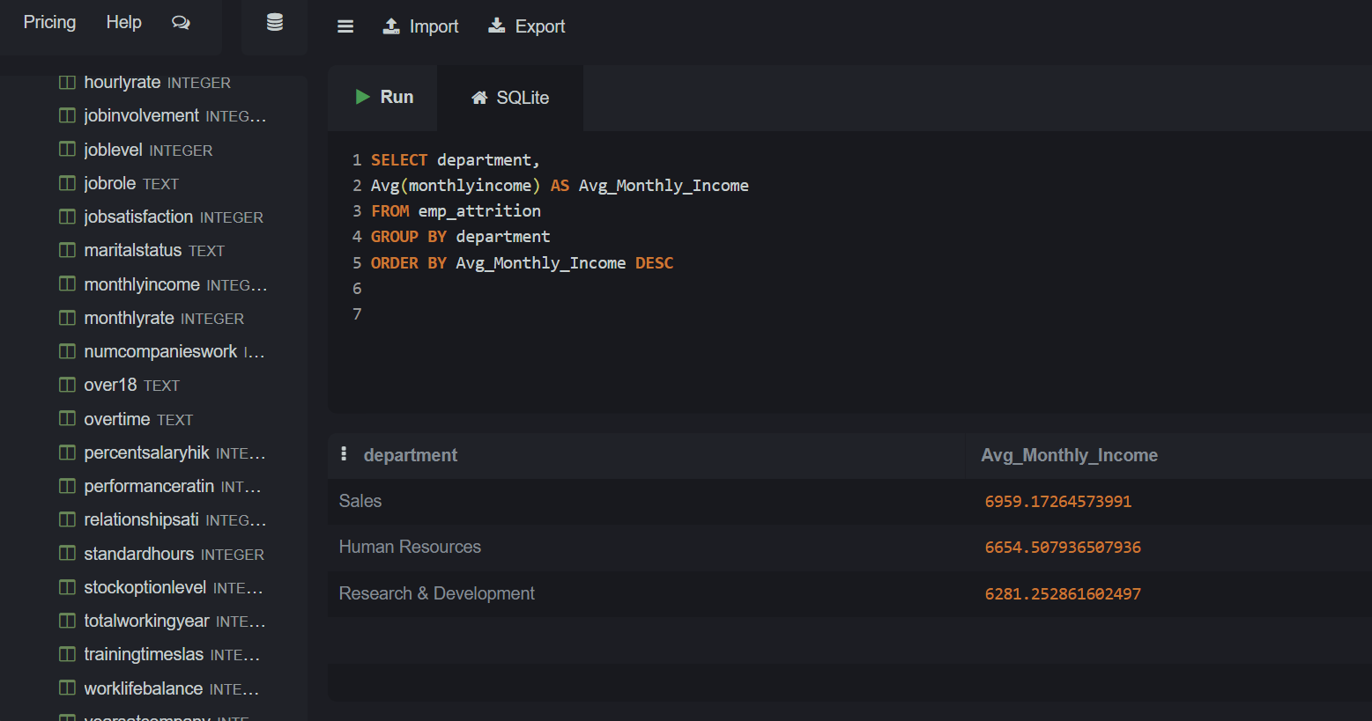

- Employees With More Than 10 Years of Experience
SELECT *
FROM emp_attrition
WHERE yearsatcompany>10
order by yearsatcompany ASC
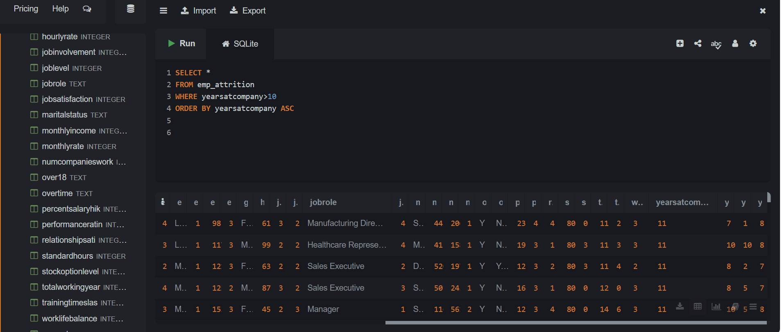

- Highest Paid Employees
SELECT *
FROM emp_attrition
order by monthlyincome DESC
limit 10
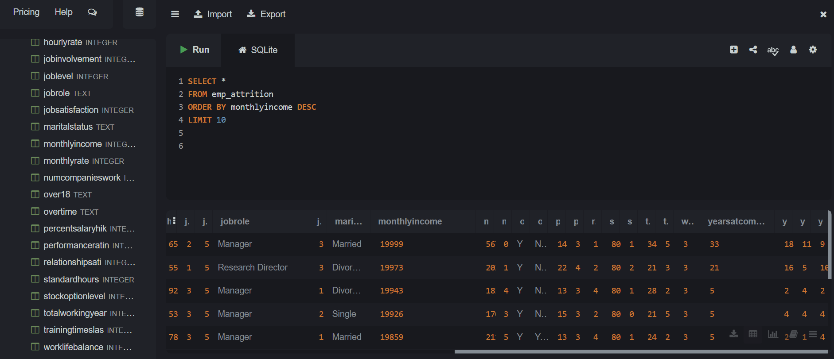
- Top Departments by Average Salary
SELECT department, '₹' || round(Avg(monthlyincome), 5) as Avg_Salary from emp_attrition
group by department
order by Avg_Salary desc
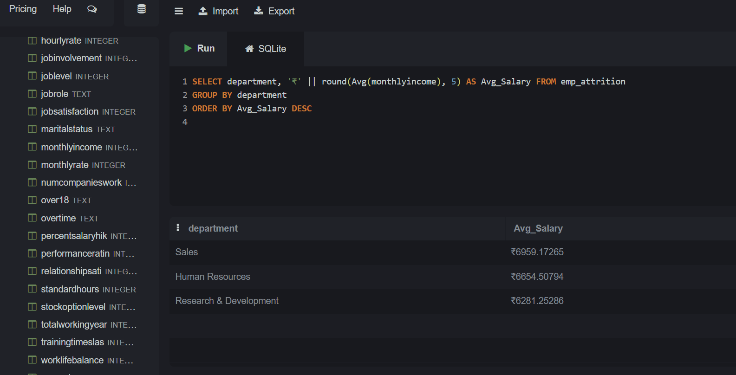

- Employees Eligible for Promotion
Select * from emp_attrition
where yearsatcompany>4 and hourlyrate>50
and performanceratin>=4 and yearssincelastpr>=3
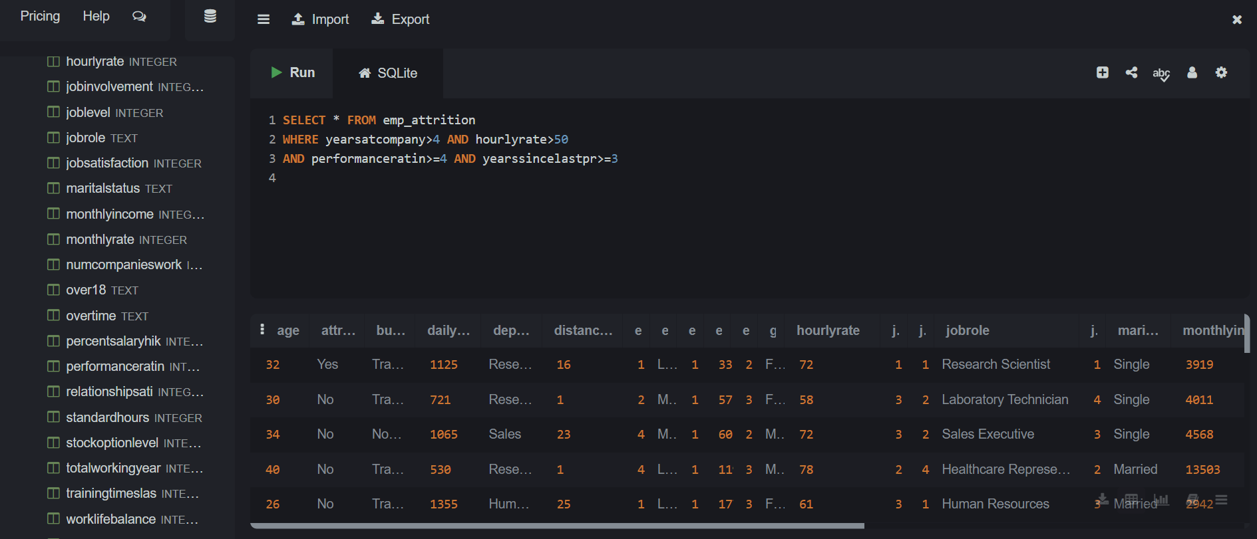

- Department-wise Employee Count
select department, Count(*) as EmployeeCount from emp_attrition
group by department
order by EmployeeCount desc
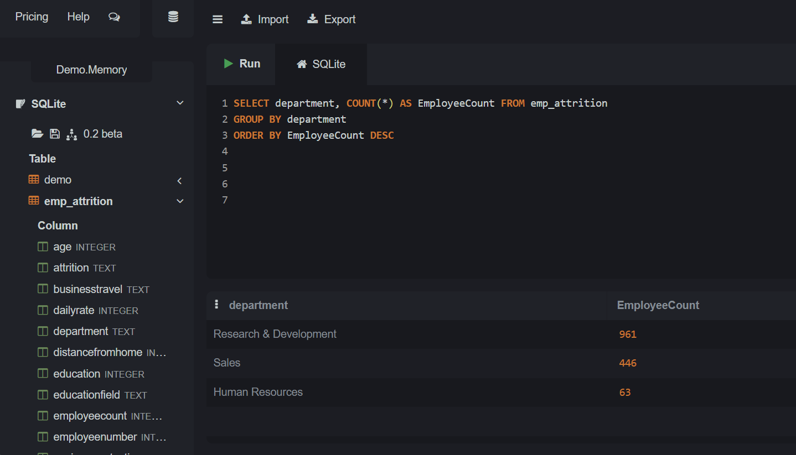
- Overall HR Summary Report
SELECT
-- Headcount Metrics
COUNT(*) AS Total_Employees,
SUM(CASE WHEN attrition = 'No' THEN 1 ELSE 0 END) AS Active_Employees,
SUM(CASE WHEN attrition = 'Yes' THEN 1 ELSE 0 END) AS Terminated_Employees,

-- Retention Metrics
ROUND(
(SUM(CASE WHEN attrition = 'Yes' THEN 1.0 ELSE 0.0 END) / COUNT(*)) * 100,
2
) AS Attrition_rate_percentage,
avg(case when attrition='No' then yearsatcompany END) AS Avg_tenure_years,

-- Financial Metrics
ROUND(AVG(monthlyincome), 2) AS Average_Salary,
MAX(monthlyincome) AS Highest_Salary,
MIN(monthlyincome) AS Lowest_Salary,
SUM(monthlyincome) AS Total_Payroll_Cost,

-- Demographics & Diversity
SUM(CASE WHEN gender = 'Female' THEN 1 ELSE 0 END) AS Female_Count,
SUM(CASE WHEN gender = 'Male' THEN 1 ELSE 0 END) AS Male_Count,
ROUND(
(SUM(CASE WHEN gender = 'Female' THEN 1.0 ELSE 0.0 END) / COUNT(*)) * 100,
2
) AS Female_Representation_Percentage
FROM
emp_attrition;
